“We also want to acknowledge what our community has said about feeling the pinch of taxes, particularly after this last legislative session,” Yelm Superintendent Chris Woods.
Well… at least he didn’t say “let them eat cake.” But he also didn’t speak to what many of us are concerned about: Cost/benefit.
What are we getting?
From around 2004-2009, Washington State partnered with a consortium of states to develop a “Common Core” set of standards for assessing school performance. The standard established a minimum level of proficiency EVERY student should be able demonstrate in Math and English (language arts) as part of their K12 experience.
OF NOTE: The Washington Teacher’s Union(s) had a significant role in developing… and, in fact, approved… the standards which were adopted in or around 2011.
As of about 2018, the test score to meet graduation requirements for math was set at a “mid-year Algebra I (9th grade) level with maybe one or two geometry questions”. Per WA SBE management, it was not and is not a college track test.
Since 2014-15, Yelm’s percent met standard, by year is: (2014-15) 14.5%, 20.8%, 26.3%, 32.1%, 33.8%, No Score, 16.6%, 16.1%, 22.8% and (for 2023-24) 23.8%.
What are “we” paying?
The following table is a summarization of the Access Version of the 2023-24 school year S-275 data (links below). The numbers are based on the “tfinal” or “Total Final Salary” column which I understand is the amount actually paid to the employee and their contracted hours.
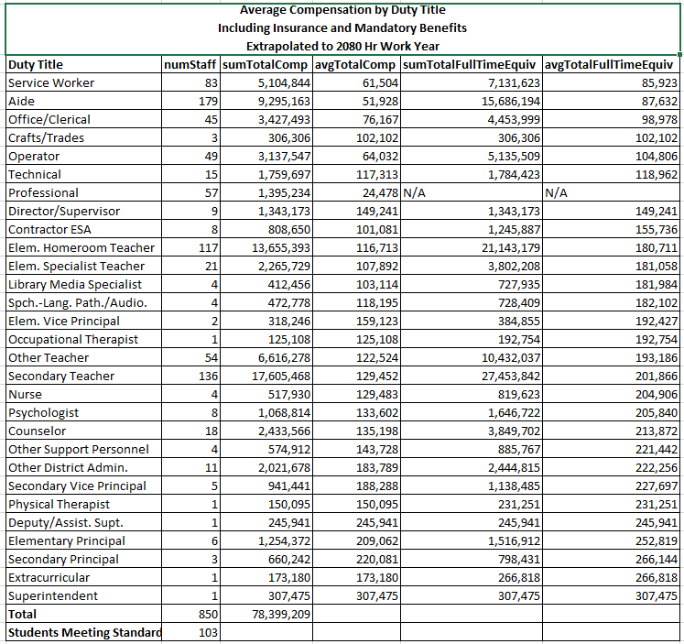
Notes:
- SumTotalComp = sum of tfinal + Insurance + Mandatory Benefits actually paid
- Insurance runs about $13,000/year per eligible employee. Mandatory benefits range from modest to $43,000.
- SumTotalFullTimeEquiv = SumTotalComp * (2080 / “Hours Reported or Contracted”)
- Students Meeting (10th Grade Minimum) Standards… what is coming of the assembly line after 11 years in the SD… 103 out of 433 meeting a minimum standard of proficiency in Math and ELA.
Should we pass the levy?
I think a review of the history of Socialism (and social research) will show… when compensation is based on “what the other guy is making” (ex: “Oly SD is paying THIS amount… we deserve a raise”) and not on “the quality of what is being produced”… you lose accountability and from there, quality.
The question, to me, is… how do we bring accountability back into our public schools? Will passing the levy do that? Or, would basing compensation on the number of students meeting standards (not just improving) be more likely to produce better results?
If the later, how might we accomplish this? Keep in mind, WA Public K12 Unions specifically rejected that provision about 10 years ago AFTER initially agreeing to it …and started a national movement through Patty Murry to remove it from the NCLB resulting in the neutered 2015 ESSA.
Or, could it be accomplished by introducing alternatives such as Charter Schools which can be held accountable… and if so, how do we do that… and at the same time… protect them from the Unions?

Links:
- Report Card: https://reportcard.ospi.k12.wa.us/
- S-275: https://ospi.k12.wa.us/safs-data-files
- S-275 Personal Reporting: https://ospi.k12.wa.us/sites/default/files/2024-10/s-275handbook2024-25.pdf
- Google AI Summary: “Wa loses certification under the NCLB”

- select [Duty Title], numStaff = count(*)
- , sumTotalComp = cast(sum(TotalComp) as money)
- , avgTotalComp = cast(avg(TotalComp) as money)
- , sumTotalFullTimeEquiv = cast(sum(TotalFullTimeEquivComp) as money)
- , avgTotalFullTimeEquiv = cast(avg(TotalFullTimeEquivComp) as money)
- from
- ( select *, TotalFullTimeEquivComp = a.TotalComp * a.FullTimeAdjFactor
- from
- ( select distinct ex.[Duty Title] , ac.AC_LastName, ac.AC_FirstName, AC_tfinsal, AC_cins, AC_cman, TotalComp = AC_tfinsal + AC_cins + AC_cman
- ,AC_ftedays, AC_ftehrs, ac_certFte
- ,AC_clasfte, AC_clasbase -- based on certFTE(%) of FDTdays*fteHrs
- ,FullTimeAdjFactor =
- CAST(case when AC_certfte > 0 then 2080 / (AC_ftedays * AC_ftehrs * AC.AC_certfte)
- when ac_clasfte > 0 then 1.0/ AC_clasfte
- else null end
- as money)

- from dbo.Yelm_S275_ac AC
- left outer join dbo.Yelm_S275_EX EX
- on AC_LastName = ex.[Last Name] and AC_FirstName = ex.[First Name]
- where [Duty Title] is not null
- )A
- -- order by a.[Duty Title]
- ) B
- group by [Duty Title]
- order by cast(avg(TotalFullTimeEquivComp) as money)

The Access version appears to contain staff from other SDs. They have been removed by using the Excel version as a filter (SQL Join).

